**Student:** Muhammad Abdullah **ID:** L00171275

**Marks and feedback**

|  |  |  |  |
| --- | --- | --- | --- |
| **Element** | **Available** | **Awarded** | **Comments** |
| Critical evaluation of cross-platform | 10 | 6 | Presentation matters, you forgot to include page numbers as commented on in early feedback. Inconsistent formatting of text. Use IRL/UK spelling not US. Incorrect referencing, Use Harvard, IEEE or ACM. Where was reference one originally published? Place verbatim quotations in italics. The introduction should set the scene of the problem/report more clearly. You mention the need to develop for different platforms but no mention of the festival application! Material on react is superficial and does not provide the reader with the level of detail required to evaluate the technology in terms of its suitability. |
| Architectural design | 10 | 4 | I recommend that you use dependency injection instead of creating new viewmodels in the constructor of the ContentPages. Just register the various pages. Software architecture is incomplete. Could you build the application with just those three classes? |
| Visual design and Prototype | 20 | 14 | The background image is fine but a little a more visually compelling/interesting image or background might be more suitable. I would carefully consider the use of colours. Red text is usually used for warning the user. The main screen uses several colours (white, black, pink, yellow, blue and red), these colours don’t constitute a cohesive colour scheme. Take a look at Apple (HIG), Google (Material design) or Microsoft UX (fluent design system) design guidelines for mobile applications. Review the guidelines on colour schemes, use of controls, application layout and user interaction.  Learn to clean the project to remove temporary files before uploading. You can delete the .vs, bin and obj folders to reduce the size of the project. I noticed that there wasn’t a .git file in the project. I highly recommend that you use version control with Git when working on software projects.  There are some user interface (UI) issues when running the application on android, the vertical stacklayout has a width request of 500 which exceeds the width of the screen resulting in text appearing offscreen. Ensure you test the application on a mobile (virtual or physical device). The navigation style is appropriate with tabs being used for the main areas of the application. The button to bring out a side bar to select days is a nice touch but dismissing it isn’t obvious. Again choice of colours could be more consistent.  Overall there is a decent amount of work within this prototype. You have displayed a good level of understanding of .NET MAUI and considering you arrived into the course late this is very impressive, well done. |
| **CA Total** | **40** | 24 | (60%) |

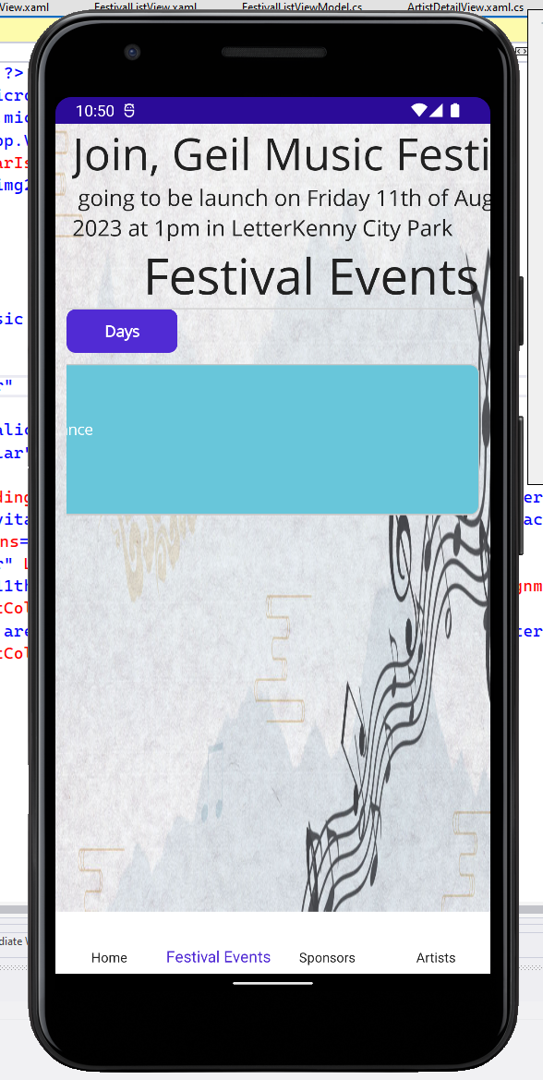



**Text appears off screen**

